**PROPOSED SOLUTION DOCUMENT**

**SKILL AND JOB RECOMMENDER**

**NOVELTY:**

The skills and the job recommendation system is basic way of job recommendations by matching with the manually entered skills in the existing research projects. In this project the skills and the jobs are identified using the data taken from the student and the jobs are recommended based on the eligibility criteria with the specified skills.

**FEASIBILITY OF IDEA**

**Description of Services**

1. Our project is to create and provide an online platform it will recommend according to the user skills.
2. Based on the person-job fit premise, we propose a framework for job recommendation based on professional skills of job seekers. We automatically extracted the skills from the job seeker profiles using a variety of text processing techniques.
3. In job recommendation systems, here are varieties of students, having different education level and skills. Based on student’s respective background details, each one of them expects to get only those job recommendations which are highly relevant for that particular student.
4. By offering job recommendations through an online platform can showcase its recommendations to fresher. It can improve their career and knowledge and allow them to view different kinds of jobs based on their skillset.

## Product/Service Marketplace

## The key problem is that most of job hunting websites just provides recruitment information to website viewers. Students have to retrieve information among those displayed by websites to find jobs they want to apply. The whole procedure is lengthy and inefficient. In addition, many e-commerce websites, uses collaborative filtering algorithm without considering user’s resume and item’s properties.

## We describe our framework for job recommendation. We automatically collect the data from the user’s input during registration and a set of profiles from the well-known LinkedIn. It is important to note that we collected more data from similar sites but, due to the validation issues, we only managed to work with these two sources in our framework.

## 

## Framework of Recommendation process

## The target audience of our project is fresher’s who finished their college and persons who are seeking to change their domain.

## Commonly, a job seeker has two ways to search a job using these sites: 1) doing a query based on keywords related to the job vacancy that he/she is looking for, or 2) creating and/or updating a professional profile containing data related to his/her education, professional experience, professional skills and other, and receive personalized job recommendations based on this data.

* Knowing the age demographic of the platform you are advertising or marketing on is very important. This is mainly down to the fact you need to know if your target audience will have any exposure to your business. If they don’t, then it is a pointless exercise. Due to LinkedIn being more professional it does have a very diverse range of ages.
* The job recommendations sites itself is heavily dominated from 21 year olds to 45 year olds. This is due to having many students who are looking for their first role. A large percentage of professionals either owning, recruiting or in senior positions to finish off the age ranges.

**Business Model**

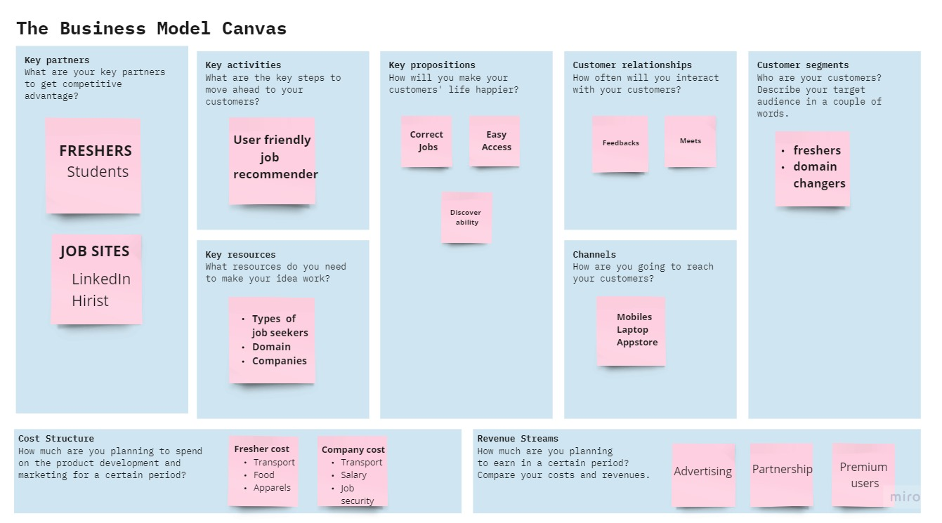

## Social impacts

## All skilled employees and fresher’s are got employed using the recommender systems.

## Suitable jobs are suggested according the skills.

## The end users can choose their own interested jobs.

## For the experienced persons it's an easy way to get jobs instead of searching outside.

## Scalability

## The recommender system will be adaptable based on the persons who are applying for the jobs.

## The infrastructure of the application should be maintained without the bugs.

## The ideas of the recommendation systems will be upgraded to the next level.

## The performance of the application will be effective and suitable to the hardware systems.